To-do list Management Application

Lab Task

Identify Routers as sub applications (or modules), and Routing table entries (Method, URI, and Resource) for the To-do list application that we have developed as our front end in React.

Example Router and Routing table entries:

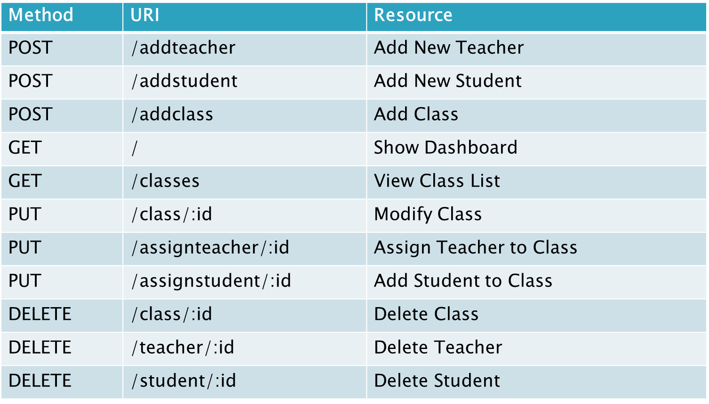

Submit as a word/pdf document. This is an individual lab task.